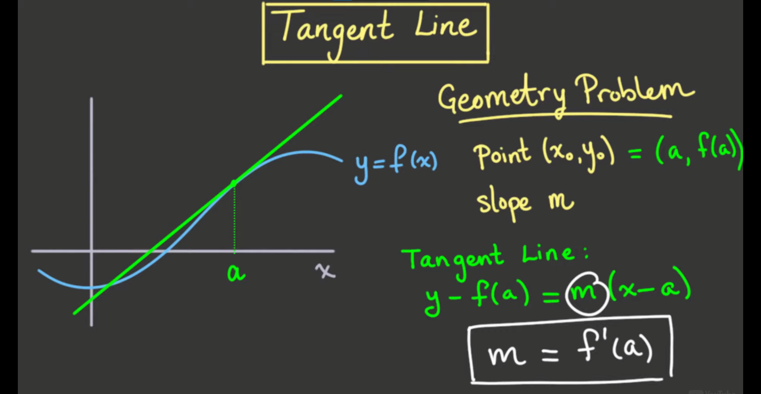

We've seen that we can draw a tangent line. There is some sense that the tangent line goes through a point of a function in a way that it doesn't cut across the function at that point. But we have to be careful.

Let's take a moment to think about what tangent lines are not. First, though, let's start with a bad way to think about tangent lines. A lot of students learn in high school that a tangent line is “a line that touches the curve in only one point." This is true if your curve is a circle, but for many other curves and functions, this is a terrible definition. Let's see why.

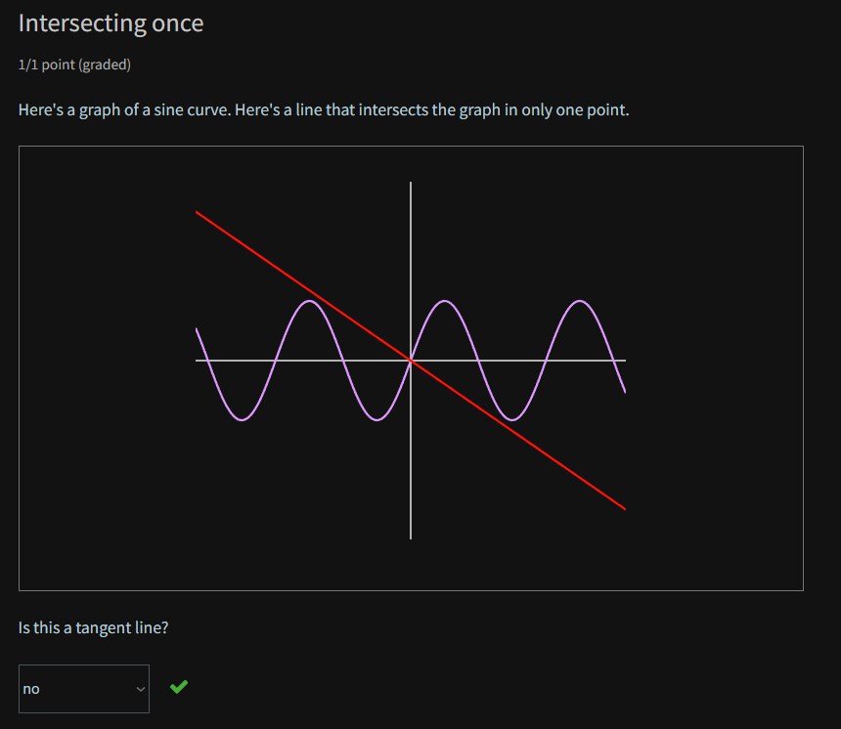

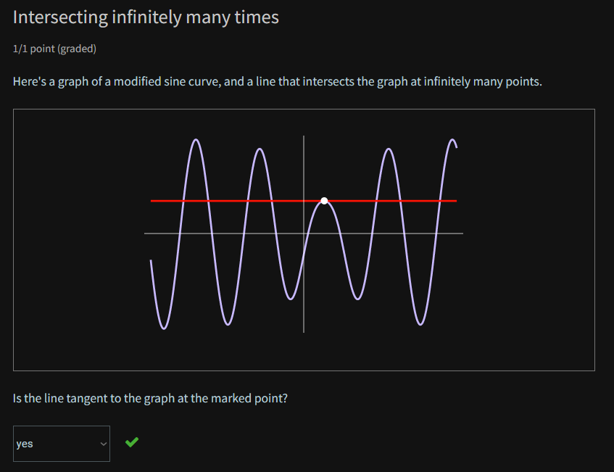

When zoomed in a point on a curve (function), the curve (function) looks like a straight line

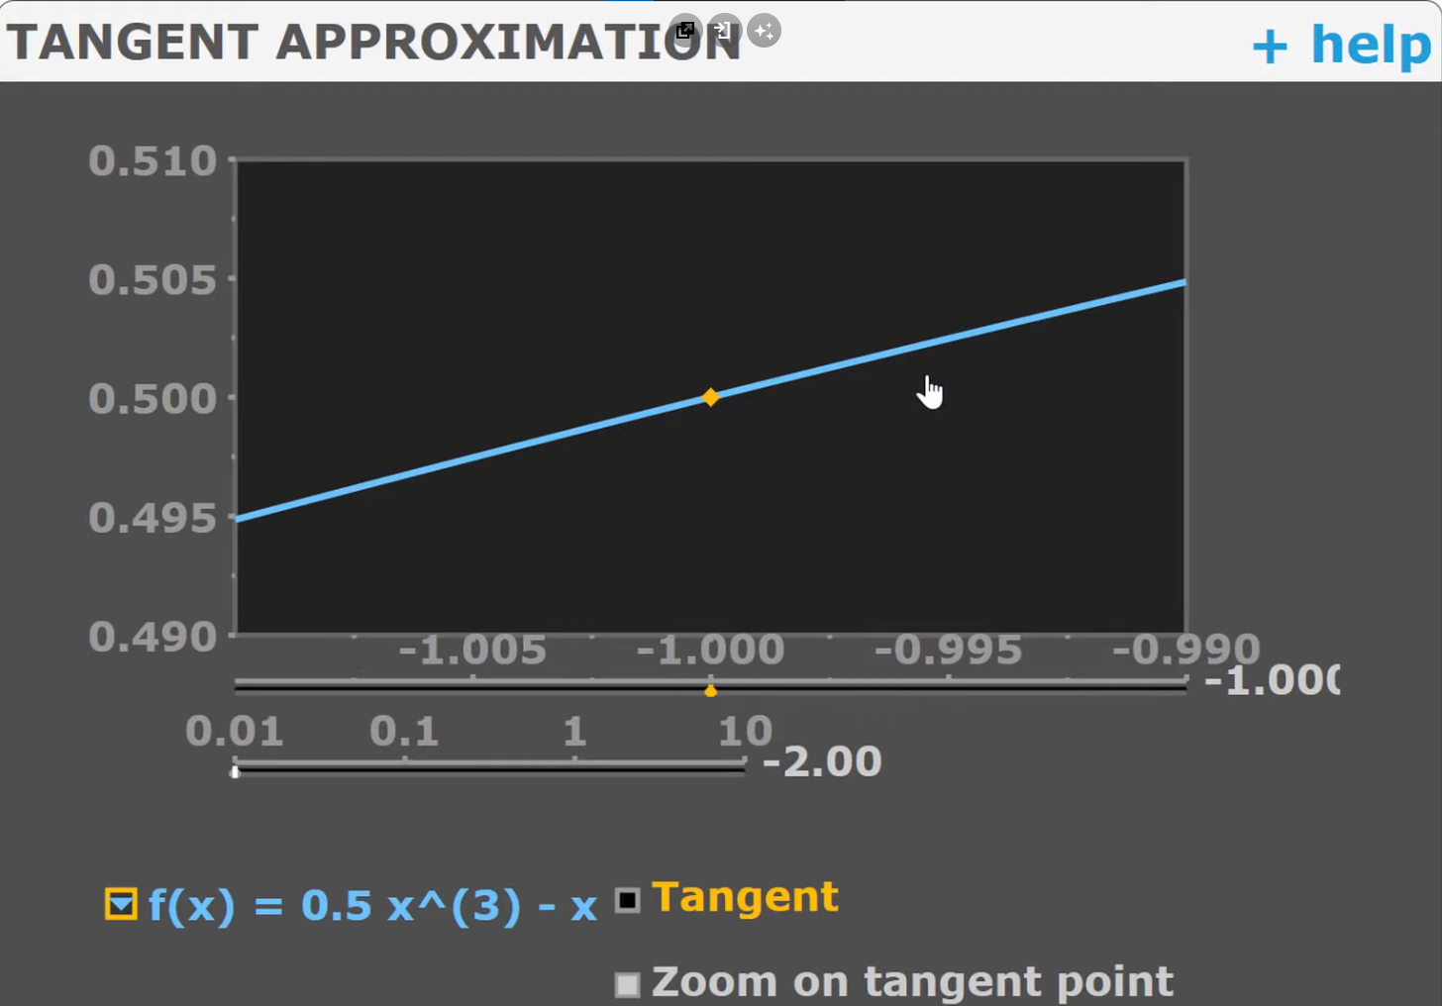

Your tangent line must point in the same direction as this curve (function)

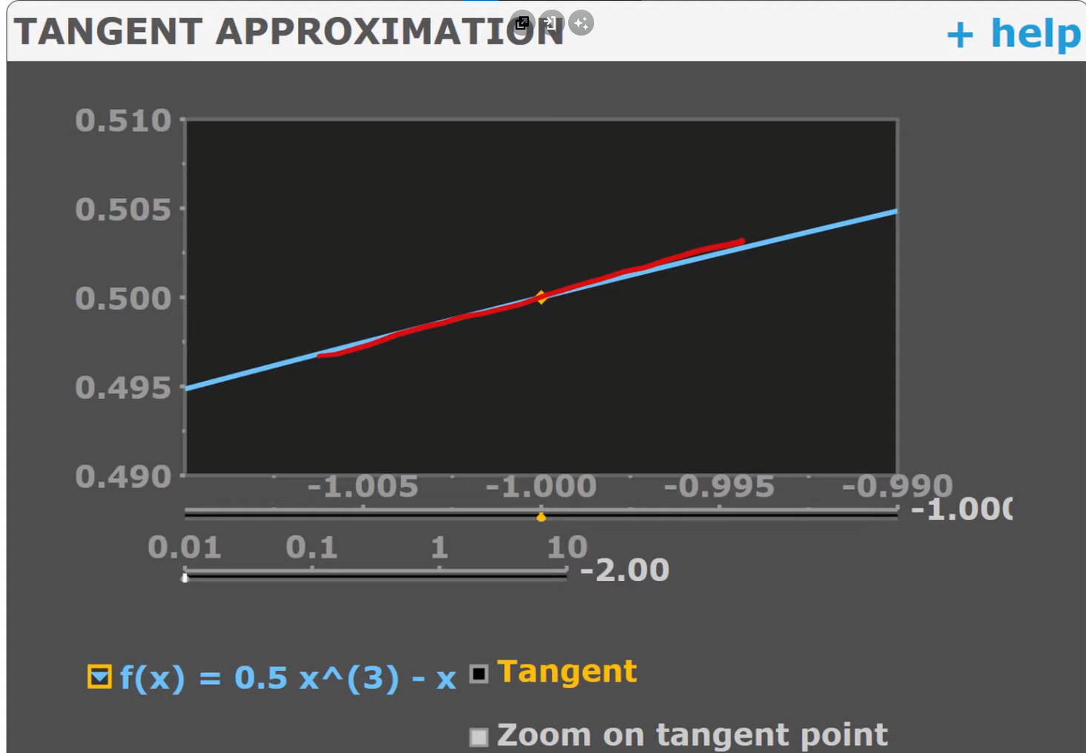

Draw the tangent line on zoomed

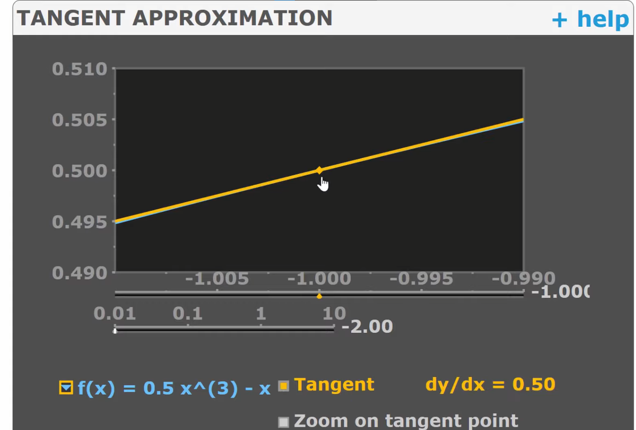

Then try to zoom it out

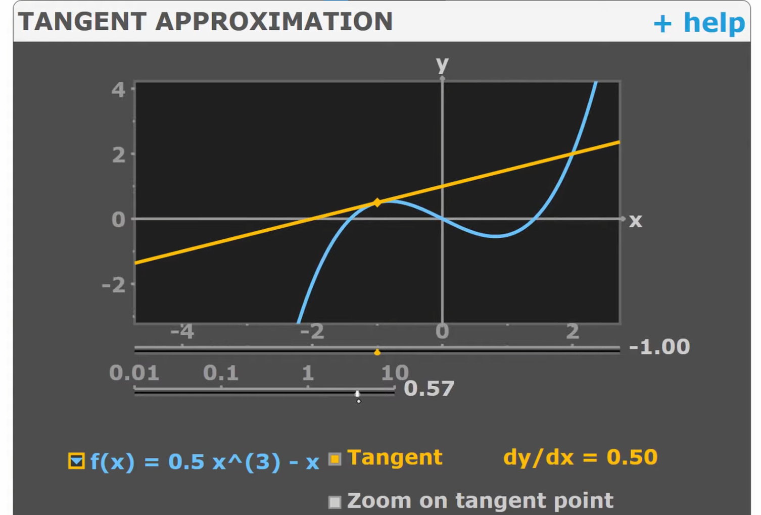

* They only agree in the small neighborhood of the curve